**CS4222: Assignment 3 (Group 6)**

**Group Members:**

Goh Cher Lin (A0112882H)

Nicholas Low Jun Han (A0110574N)

Nelson Goh Wei Qiang (A0111014J)

**TASK 1:**

**<Insert answer here>**

**TASK 2:**

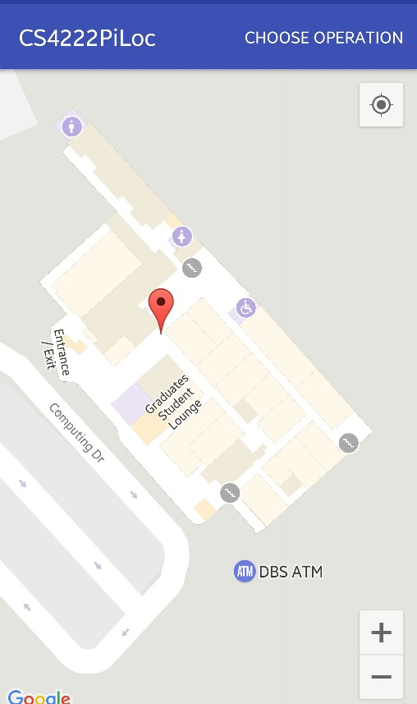

**Lat/Lng** **of location derived from localization**: (1.2950034016634164,103.77382792532444)

**Explanation of implemented localization algorithm:**

The localization algorithm that our group implemented for this task makes use of a scoring system to decide which point on the radio map best fits the fingerprint profile provided in the question.

In this algorithm, we will calculate a score for every point on the radio map. The process of calculating the scores for all the points on the radio map is as follows:

* For each of the points on the map:
* Obtain list of fingerprints
* For each fingerprint in the given list of fingerprints
* Compare MAC address with the each of the fingerprints in the point
* IF match is found:
  + Find absolute RSSI difference
  + Based on scoring system, add the appropriate score to the cumulative score of the current point (corresponding to the difference found in Step 1.2.1.1)
  + Break and move on to the next fingerprint on the list of given fingerprints
* ELSE:
  + Move on to next fingerprint on list of given fingerprints
* Check which point has the highest cumulative score among all the points in the radio map
* The point with the highest score will be assigned as the location to return as the user’s location

The scoring system used in the current algorithm in the program is as follows:

|  |  |
| --- | --- |
| Absolute RSSI Difference | Score |
| 0 – 5 | 10 |
| 6 – 10 | 6 |
| 11 – 20 | 3 |
| 21 – 30 | 1 |

As can be seen, the scoring system is an arbitrary one with custom values pegged to each category of difference. It is through such a scoring system that we aim to give more weight to points on the radio map with fingerprints where their MAC addresses not only match with the given ones, but more importantly, have very similar RSSI values.

For example, suppose we have 2 points on a radio map:

A Fingerprint: MAC Address – 1, RSSI – 43

B Fingerprint: MAC Address – 1, RSSI – 34

Given the user’s location where his/her phone detects:

Fingerprint: MAC Address – 1, RSSI – 33

We would assign point B with a higher score of 10 points since absolute difference = |34 - 33| = 1, while assigning point A with a lower score of 6 points since absolute difference = |43 – 33| = 10

**TASK 3:**

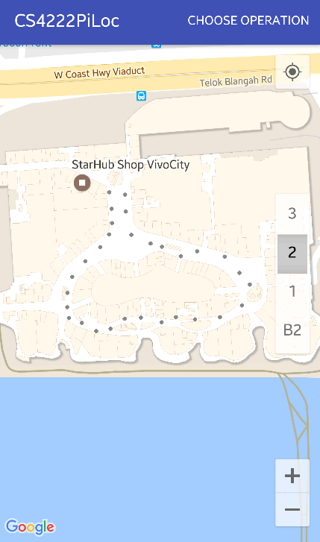

*Vivocity, Level 2*

**Question 1**

**Part I: What is the estimated localization error for this floor (in meters)?**

From the radio map that we created for Vivocity Level 2, it can be seen that we have a total of 30 points spanning the 140,000 m2 of gross floor area. Using the assumptions that the length and width of the mall is 1:1 (which will not be accurate but provides ease of calculation for this approximation), we will have:

* 1 point for every 140,000/30 = 4,666.67m^2
* With the assumption that length == width, 1 point is found every 4,666.67 ^ (0.5) = 68 meters
* Therefore, the estimated maximum localization error for this floor will be ½ * distance between points = 34 meters.

However, we know that from our radio map, the points gathered are mostly around the perimeter of the floor since the floor plan is designed in such a way that a large portion the middle area of the floor is empty space. Therefore, we would expect the localization error to be proportionately minimized alongside this decrease in the available floor space.

**Part II: Will the accuracy increase as more fingerprints are collected (e.g., the floor is covered by more walking rounds)?**

It depends on what does accuracy mean in this case.

We would say that the localization is more accurate in the sense that by having more fingerprints per point on the radio map to compare with the set of fingerprints obtained by the user’s phone at his/her location, the algorithm will be able to more precisely choose the most suitable point on the radio map as his/her location.

On the other hand, the localization error is not minimized since the number of points does not increase when more rounds are made to obtain more fingerprints per point. Hence, if “accuracy” is based on this criterion, then we think that accuracy does not increase.

**Part III: Do all locations in this floor have same localization errors?**

No, the localization error is not consistent across all locations in this floor. This can be seen from our generated radio map that the points where we collect fingerprints from are not consistently spaced. Hence, certain locations with a lower density of points will have a larger localization error as compared to locations on radio map with a higher density of points.

**Question 2**

We think that localization accuracy is affected by a combination of three factors:

1. Density of points on the radio map, which affects localization errors.   
   As demonstrated in the figure below, the precision of the obtained user’s location through localization heavily depends on the available points to select his/her location from.

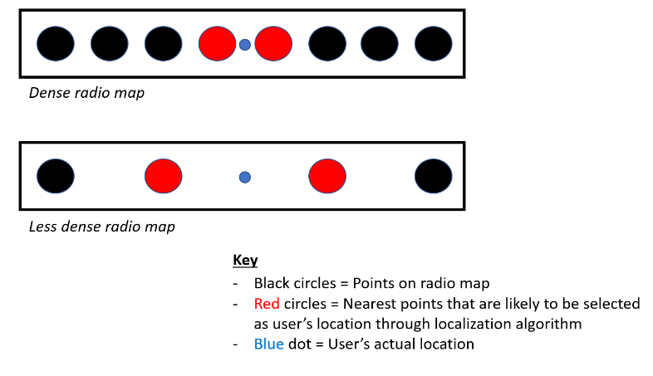

1. Number of fingerprints per point on the radio map.  
   The number of fingerprints available for comparison in each point of the radio map to the set of fingerprints obtained by the user’s phone at his/her location determines how accurately the algorithm will be able to calculate the most likely point on the radio map that the user is closest to.
2. The localization algorithm used in determining which point the user is closest to.

As seen in Part 2 of this Programming Assignment, we can see that the algorithm used in localization plays a very significant role in making use of the available data to find the closest possible point on the radio map.

**Question 3**

With our answer for question 2, our group thinks that the localization accuracy can be increased by:

1. Increasing the density of the radio map, which allows the minimization of localization error
2. Increasing the number of fingerprints per point on the radio map by walking more rounds during mapping process.
3. Have a more effective localization algorithm that will be able to find the closest possible point on the radio map based on the fingerprints collected by the user’s phone and those available in the nearby points around the user’s location.
4. Ensuring that the points on the radio map are uniformly distributed as much as possible, so that the possible localization error is kept consistent across all locations in the floor